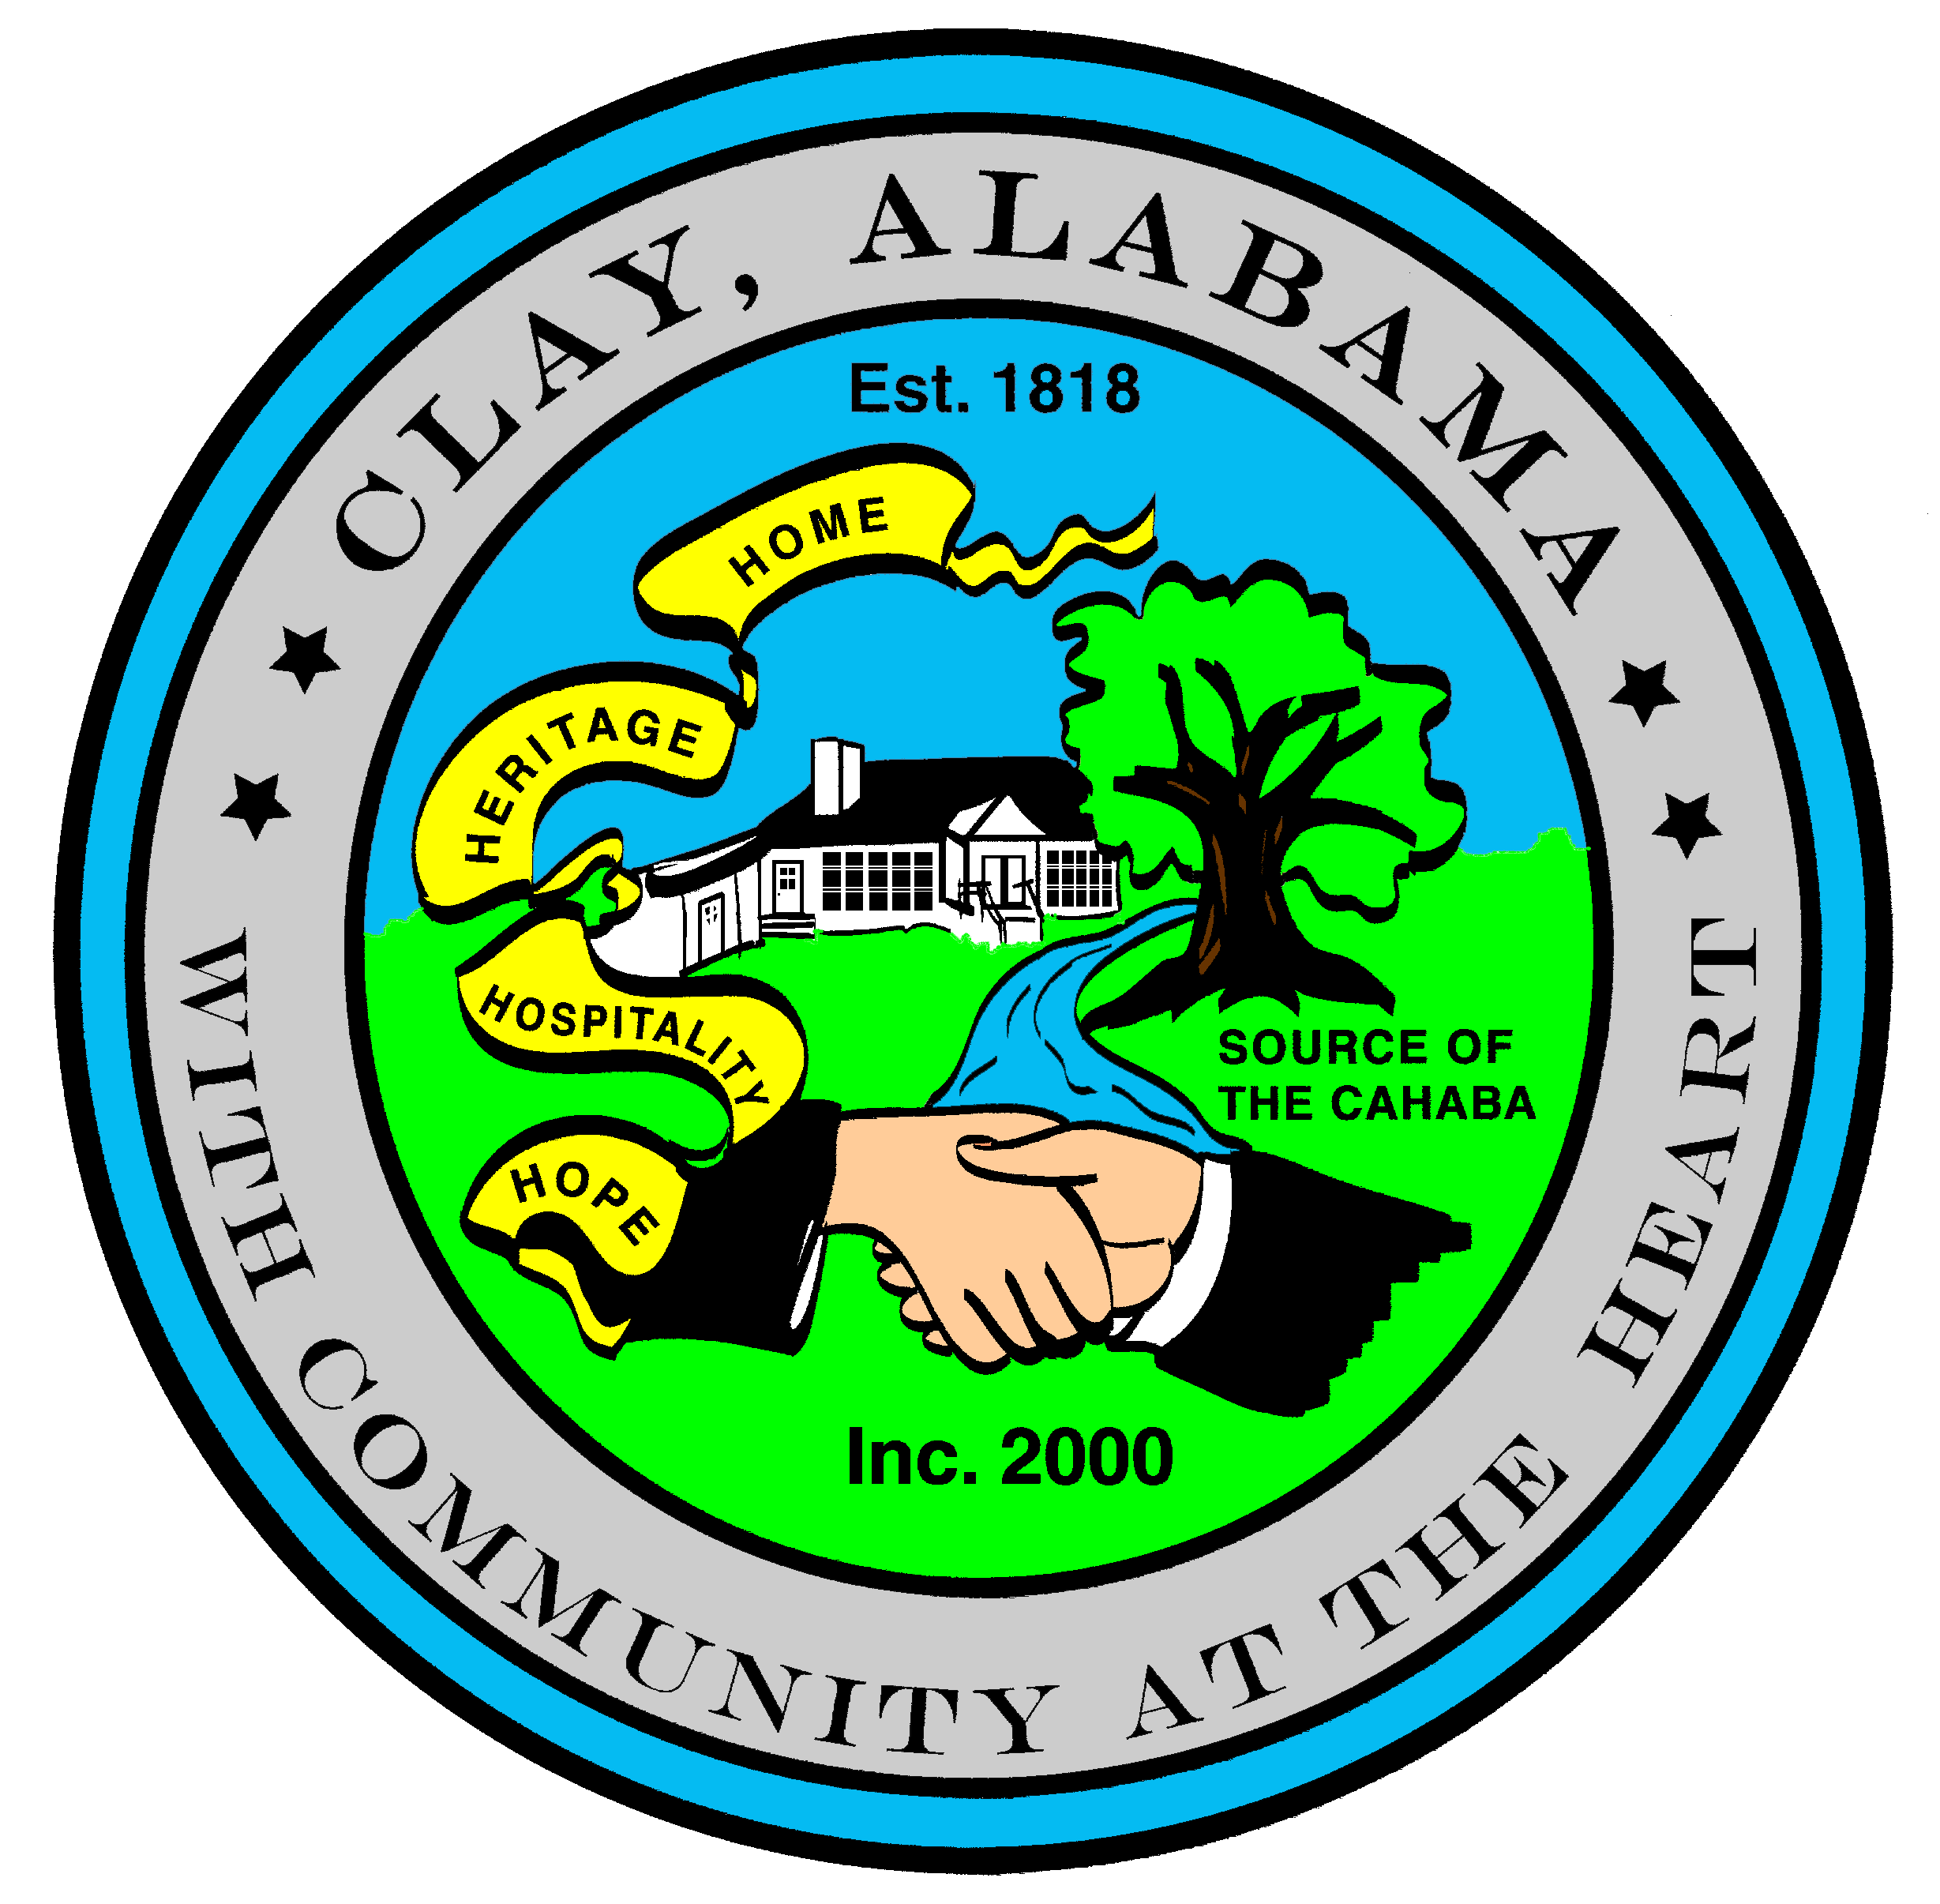
City of Clay
P.O. Box 345
Clay, AL 35048-0345
www.clayalabama.org

AGENDA
CITY COUNCIL MEETING
June 27, 2017

- Call to Order

- Prayer

- Pledge to the Flag

- Roll Call

- Approval of minutes
Pre-Council and Regular Council Minutes: June 13, 2017

- Approve Agendas
Approve Meeting Agenda
Approve Consent Agenda (Financial)

- Mayor and Council Comments
  - Mayor Webster
Proclamation 2017-03 A Proclamation Recognizing Ian Van Winkle
  - Councilor Baker
  - Councilor Becky Johnson
  - Councilor Bo Johnson
  - Councilor Locke
  - Councilor Thackerson

- Reading of Petitions, Applications, Complaints, Appeals, Communications, etc.

- City Manager’s Report/Auditing Accounts
- Public Hearings
A-2017-03, Annex 5502 Jeremiah Lane
A-2017-04, Annex 5506 Jeremiah Lane
A-2017-05, Annex 5916 Dewey Heights Road

- Resolutions, Ordinances, Orders, and other business
Enter Unanimous Consent
Ordinance 2017-00 An Ordinance Annexing 5502 Jeremiah Lane
Ordinance 2017-00 An Ordinance Annexing 5506 Jeremiah Lane
Ordinance 2017-00 An Ordinance Annexing 5916 Dewey Heights Road
Resolution 2017-18 A Resolution to Award a Bid for Demolition of Unsafe Buildings and/or
Structures, 5504 Spanish Trace
Resolution 2017-19 A Resolution to Award a Bid for Demolition of Unsafe Buildings and/or
Structures, 6884 Elliott Road
Resolution 2017-20 A Resolution to Award a Bid for Demolition of Unsafe Buildings and/or
Structures, 7778 Taylor Shop Road
Resolution 2017-00 A Resolution Declaring Weeds a Nuisance
End Unanimous Consent

- Public Comments

- Adjourn
Next City Council Meeting –Tuesday, July 11, 2017

